

DEPARTMENT OF COMPUTER SCIENCE AND ENGINEERING

Course: CSE 391
Name: SHUTIRTHA ROY
ID: 18301028
Email: shutirtha.roy@g.bracu.ac.bd
Project Title: To understand the technology

Project Features:
By the end of this course, implemented features:
- Registration System
- Login System
- Admin Panel
- User Panel
- Add to Cart Option
- Add New Book Products
- Edit/Update Individual Book Products
- View Books According to Category
- Individual Book’s Few Pages Preview Before Purchase
- User’s Ordered Books View With Delivery Date
- Admin All Book Purchased Book View With Delivery Date
- Upload Images And Pdf When Adding A Book
- Delete A Book Along With Image And Pdf
- Validation For Any Input Inserted

Screenshots:

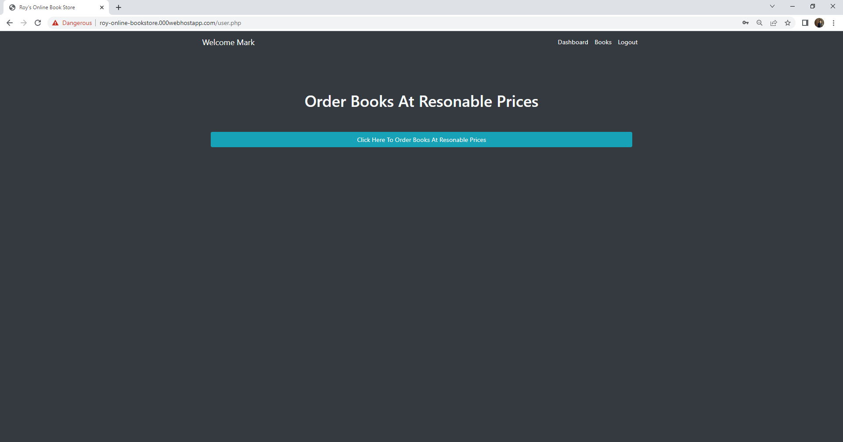
Users when logged in. They have the option to go to the view page of Books to Buy Their Desired Product.

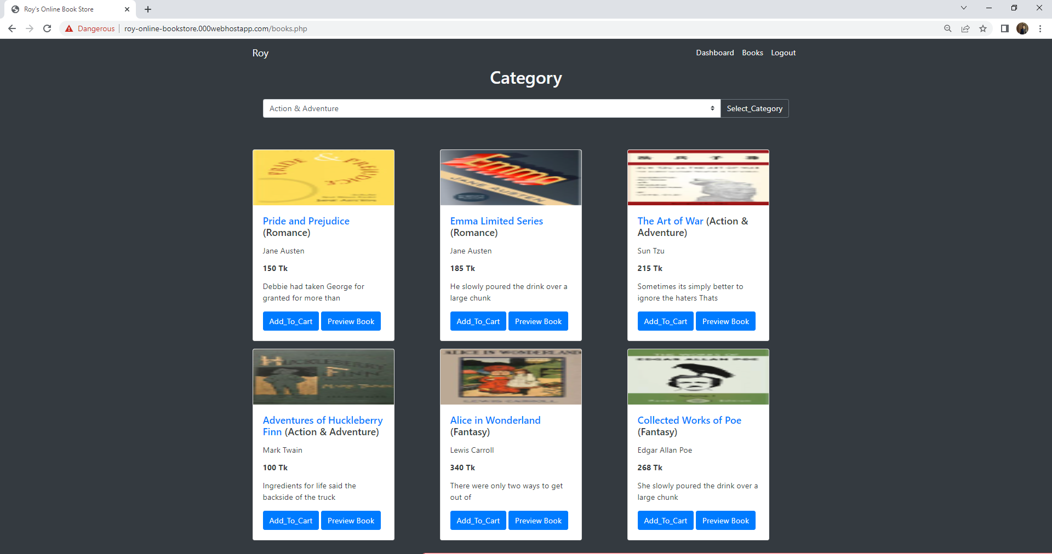
When logged in users can Add To Cart books and also Preview pdf of Few Pages of Book.

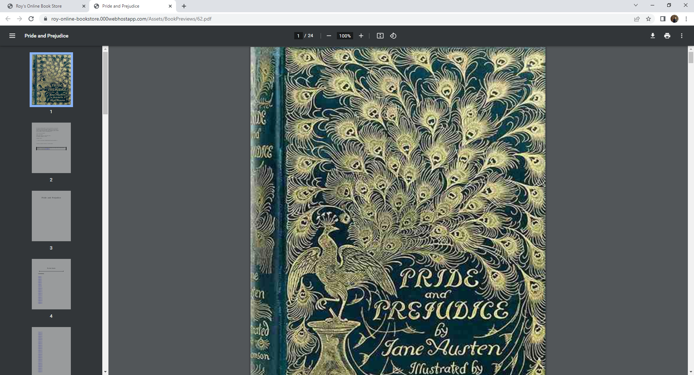
This window is opened after clicking on Preview Book. Users can read pdf of few pages to check whether they want to buy the product or not.

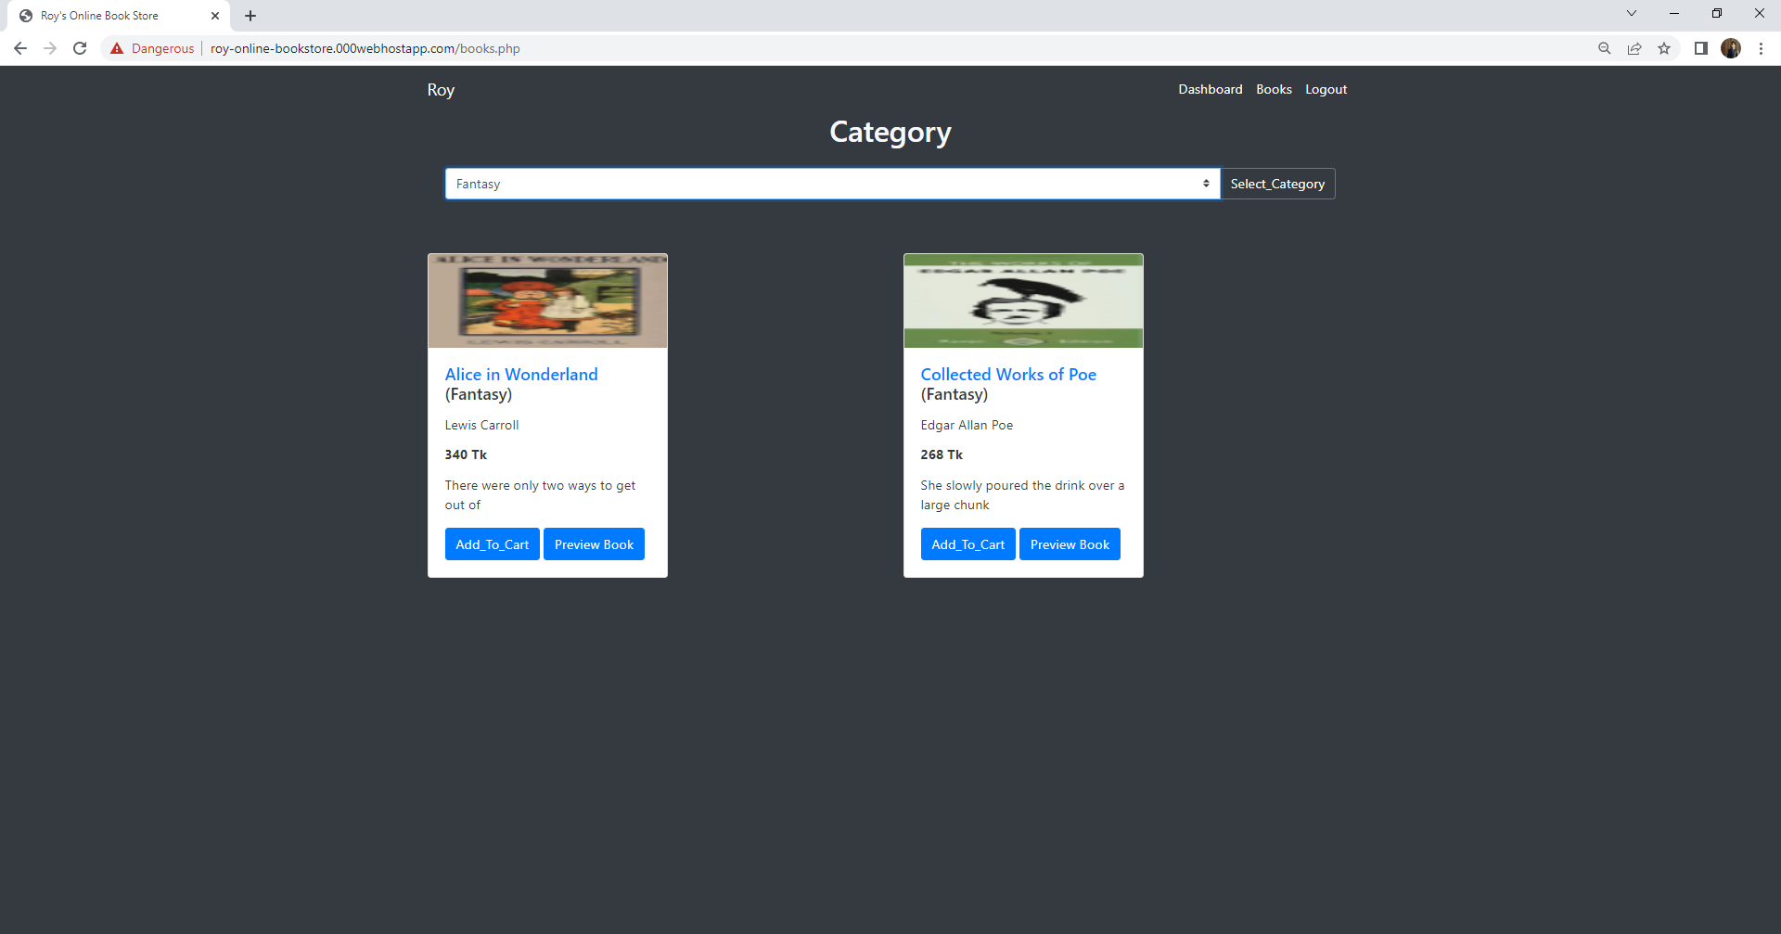
Books can be viewed according to this category. For this part “Fantasy” Category is selected.

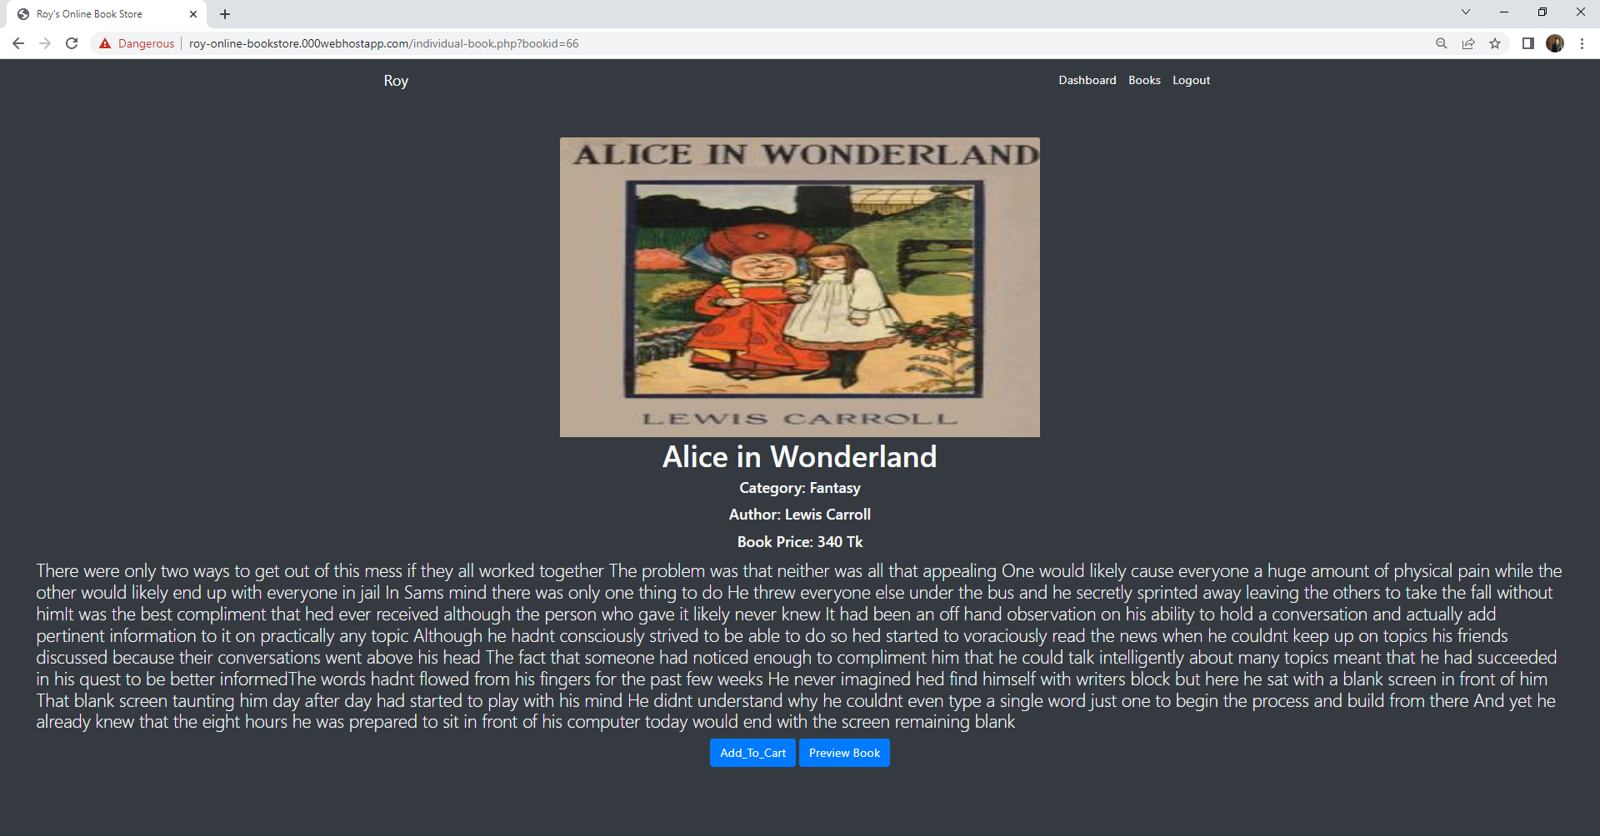
After clicking on the Book Title “Alice in Wonderland”, users can read the whole description of the book and have a better view.

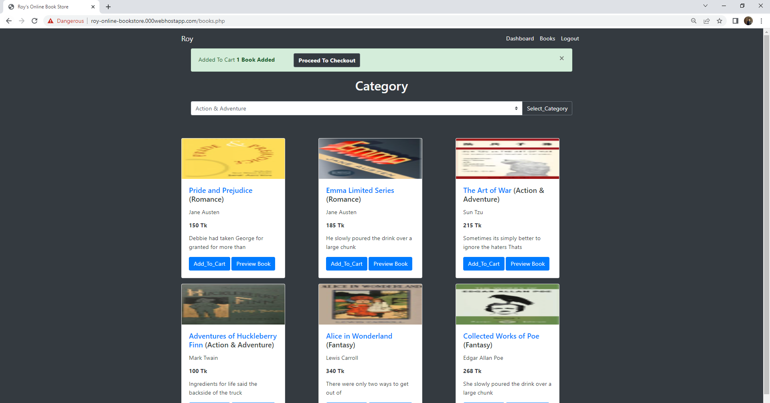
After selecting Add To Cart in a Book, users will have the option to Proceed To Checkout or add more books to cart.

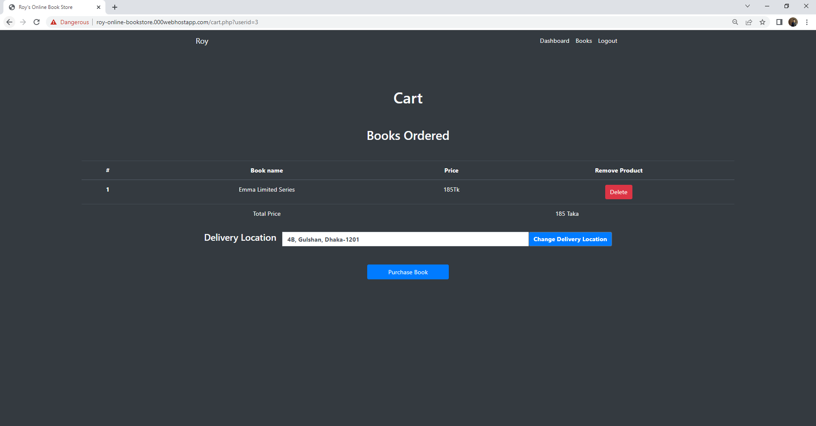
After clicking proceed To checkout, users will have the option to delete the item they selected and they will also be able to change their location which was already entered during their registration.

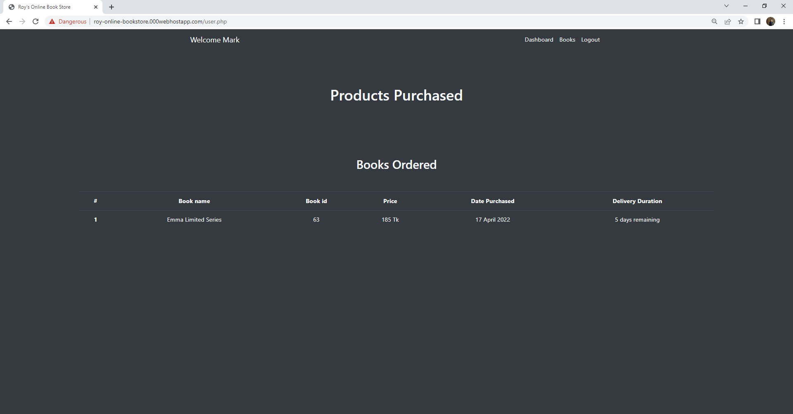
After clicking on Purchase Book, it would show the product details. The delivery duration will turn Green after 5 days, as the product has been reached to their house.

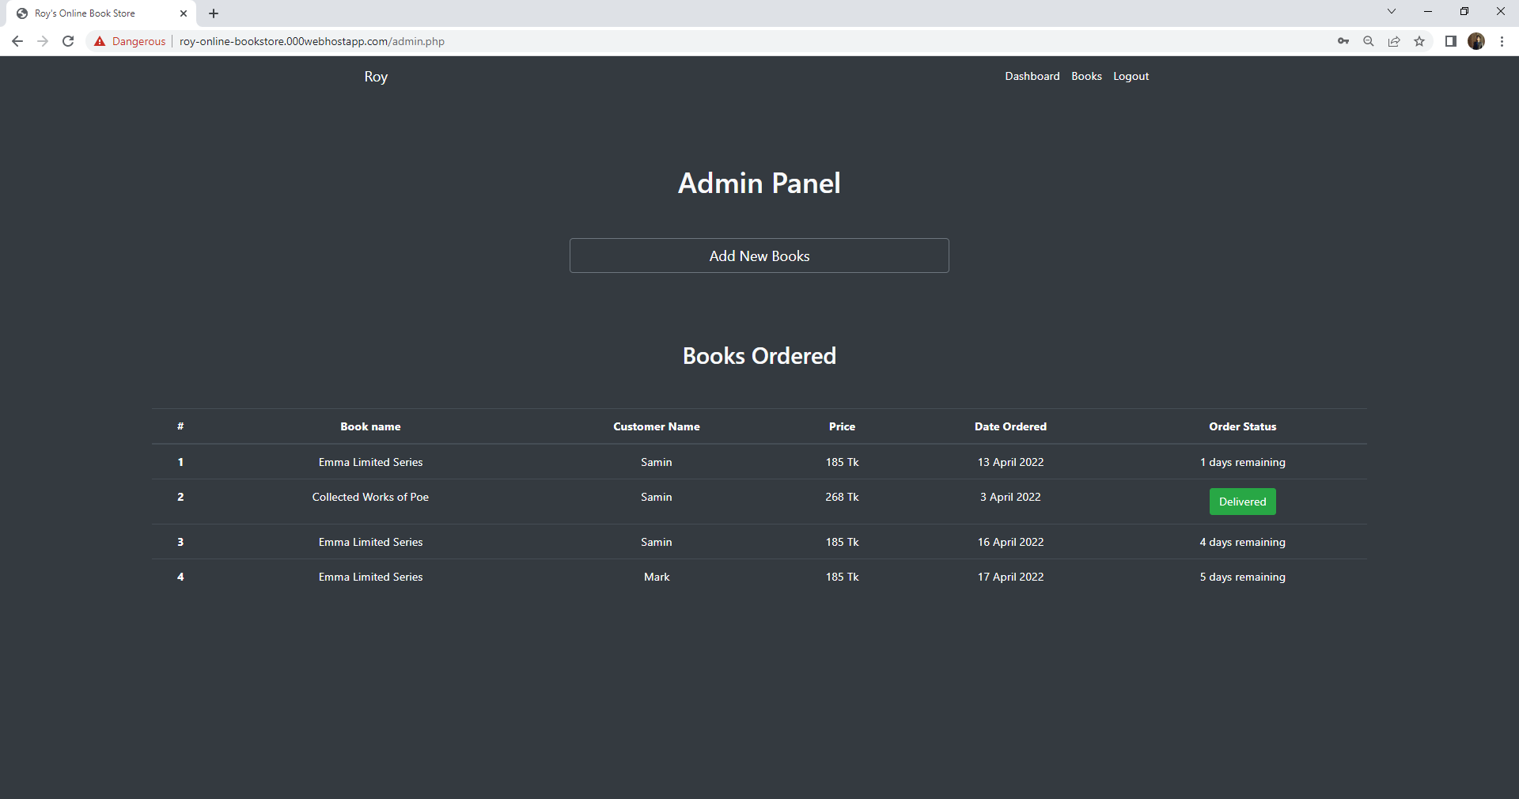

Admin panel to view all the books ordered by the users along with order status.

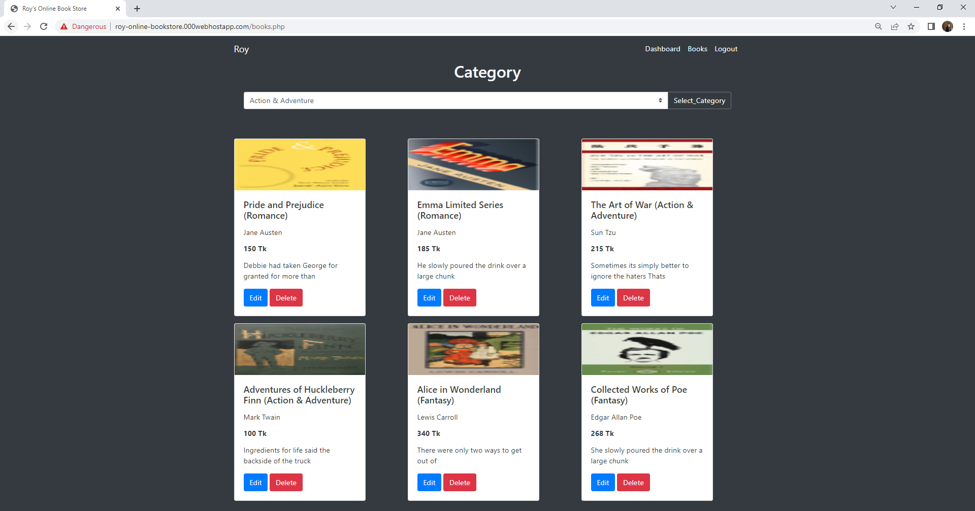

Book’s Edit Option To Make Any Changes And Delete Option To delete each book along with its image and pdf.

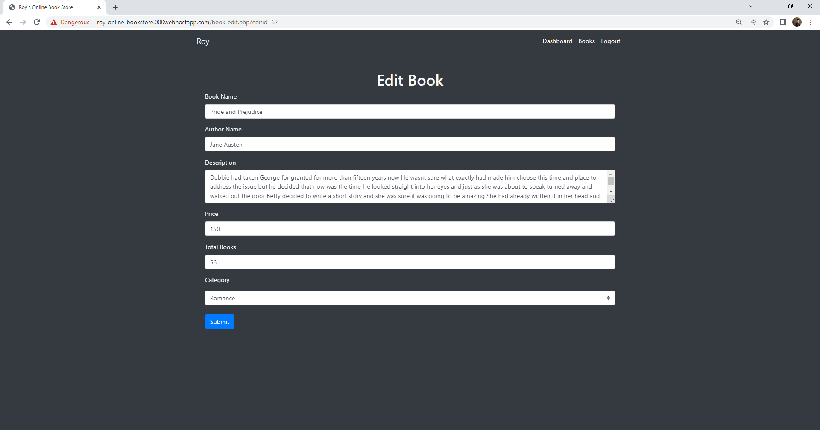
Any changes such as name, author name, description, price, total books and category can be changed here and then updated to database.

Online Resources used:
a) Reference:
- https://www.w3schools.com/, https://getbootstrap.com/ website.
- https://manybooks.net/ for books image and pdf.

Future Enhancements:
Following enhancement can be added to the current system which will improve the system.
- Books Count Feature for stopping the user for buying the product when no books are left.
- Payment Gateway Integration for users who wants to pay online.
- Email the books purchased for each product bought.
- Front End Framework to stop the website from refreshing every time a link is clicked.
- REST API feature to further use the online book system who as a Mobile Application.
- Verification Code To be sent to each user when registered so that any unknown email cannot be used for login.
- MVC Pattern to be used so that new features can be added more easily.
- Book’s pdf to be viewed from the same page instead of a new one.
- Books image and pdf allowed to edited.
- User’s cancel order option can be added.
- Coupon code can be introduced.

